**Chapter 8 Receipt**

This section manages and keeps track all of your receipts.

You can generate receipt easily with predefined category and locate a receipt quickly with the system’s search function.

This system is able to generate a receipt with more than one bill or without bill.

*In This Chapter :*

*8.1 Receipt*

*8.1.1 New Receipt (Office A/C)*

*8.1.2 New Receipt (Office Account) – Cash*

*8.1.3 New Receipt (Clients’ A/C) – MHIT*

*8.1.4 New Receipt (Clients’ A/C) - Others*

*8.1.5 Manage Receipt*

*8.1.5.2 Delete Receipt*

*8.2 A/R Receipt*

*8.2.1 New A/R Receipt (Office A/C)*

*8.2.2 New A/R Receipt (Clients’ A/C)*

*8.2.3 Manage A/R Receipt*

*8.2.3.2 Delete A/R Receipt*

*8.3 Contra Bill*

*8.3.1 New Contra Bill (Clients’ A/C)*

*8.3.2 New Contra Bill (Office A/C)*

*8.3.3 Manage Contra Bill*

*8.3.3.2 Delete Contra Bill*

*8.4 Cheque Returned Function*

*8.5 Manage Returned Cheque*

**8.1 Receipt**

* To open ‘**Receipt**’ window, click **Receipt** on the navigation bar.

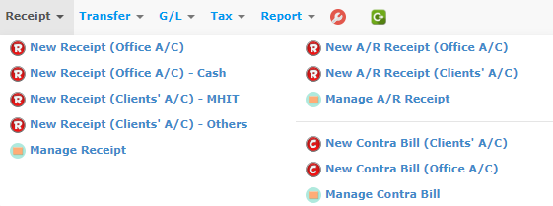

**8.1.1 New Receipt (Office A/C)**

This function should be used to generate a receipt for office account.

* To begin, choose ‘**New Receipt (Office A/C)**’.
* Receipt No. is mandatory (auto generate or manual type in is according to ref no setup).
* In the pop-up window will display as below, fill in necessary information.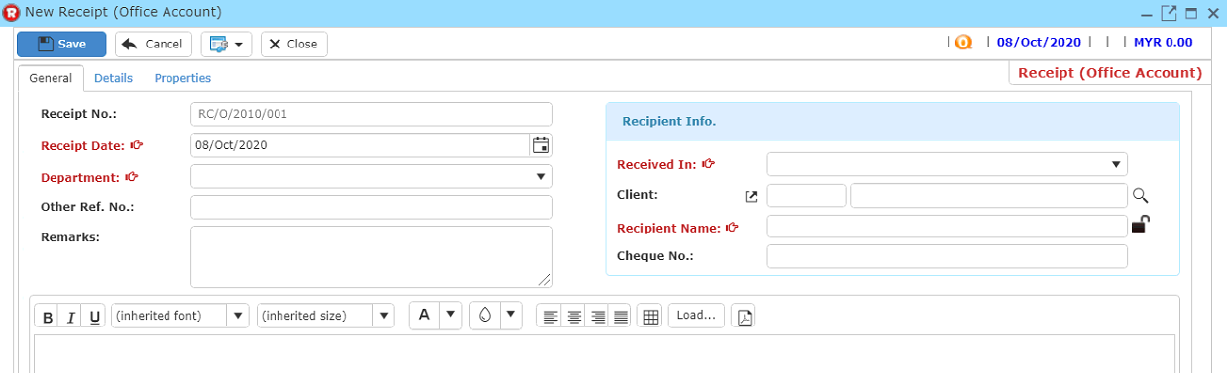
* An item must be added to the receipt to generate receipt. Click ‘**Details**’ tab, a form as shown in ‘*Figure: Receipt-Details’* will show up.

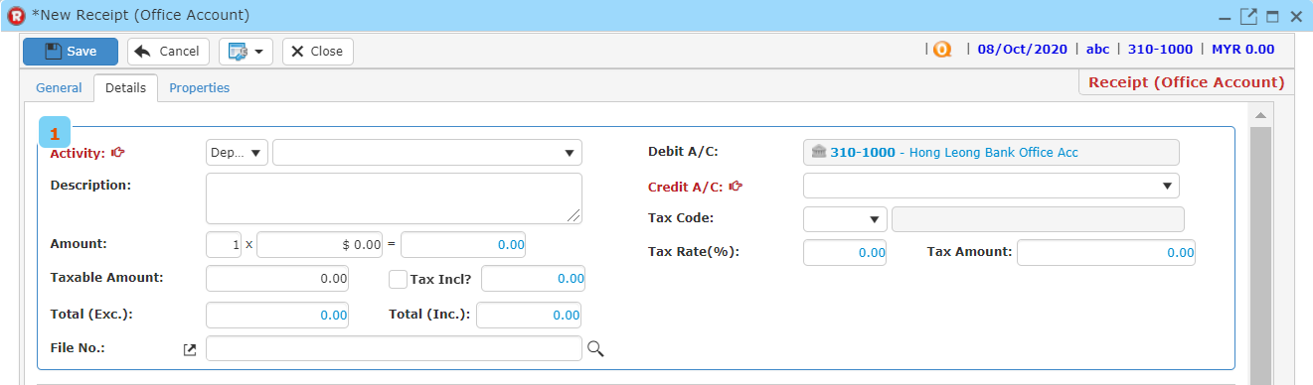

* Type amount for each item in the receipt.
* Click ‘**Add’** button to add item into the record list.
* You may also click ‘**Remove**’ button after clicking on the item that you wish to remove to remove the item from the record list.
* Then, click button to search file no.
* Enter searching criteria then click the ‘**Search**’ button.

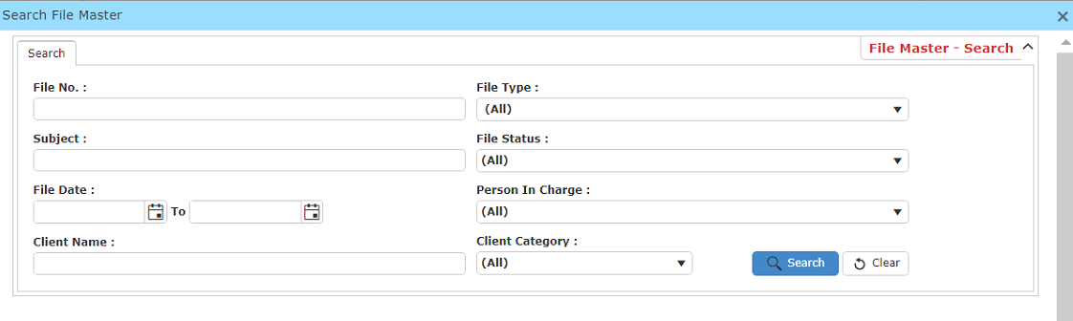

* A result list will be displayed and choose the file you want to be linked with the receipt.

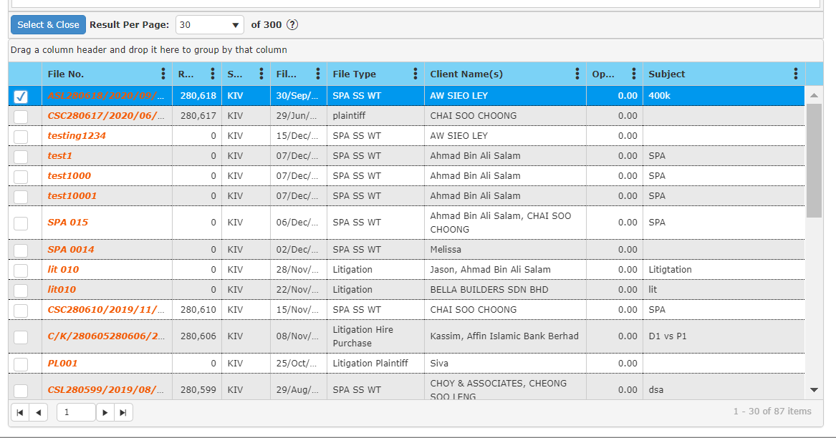

* Click ‘S**elect & Close**’ to proceed.
* Once you have completed, click ‘**Save**’ to save receipt information.
* Click ‘**Preview**’ to have a look at the receipt, and you may print out there receipt here.

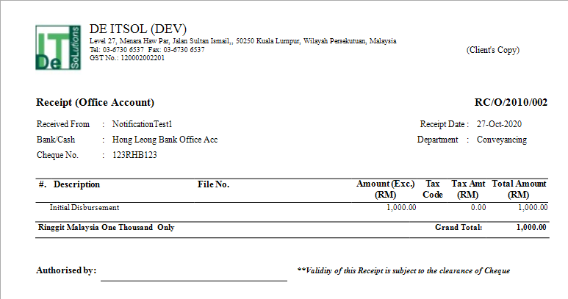

**8.1.2 New Receipt (Office Account) – Cash**

This function should be used to generate receipt when the payment method is by cash.

* To begin, choose ‘**New Receipt (Office Account) - Cash**’.
* Receipt No. is mandatory (auto generate or manual type in is according to ref no setup).
* In the pop-up window will display as below, fill in necessary information.

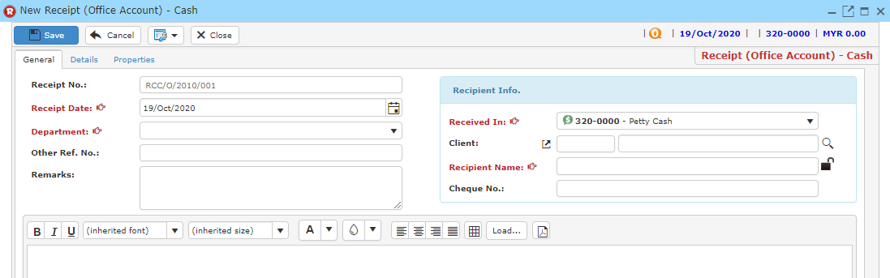

* An item must be added to the receipt to generate receipt. Click ‘**Details**’ tab, a form as shown in ‘*Figure: Receipt-Details’* will show up.

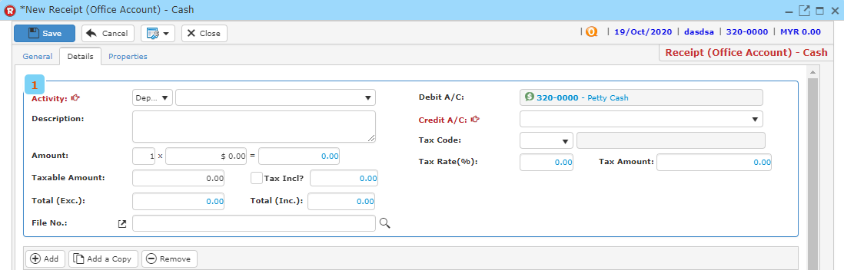

* Type amount for each item in the receipt.
* Click ‘**Add’** button to add item into the record list.
* You may also click ‘**Remove**’ button after clicking on the item that you wish to remove to remove the item from the record list.
* Then, click button to search file no.
* Enter searching criteria then click the ‘**Search**’ button.



* A result list will be displayed and choose the file you want to be linked with the receipt.



* Click ‘S**elect & Close**’ to proceed.
* Once you have completed, click ‘**Save**’ to save receipt information.
* Click ‘**Preview**’ to have a look at the receipt, and you may print out there receipt here.

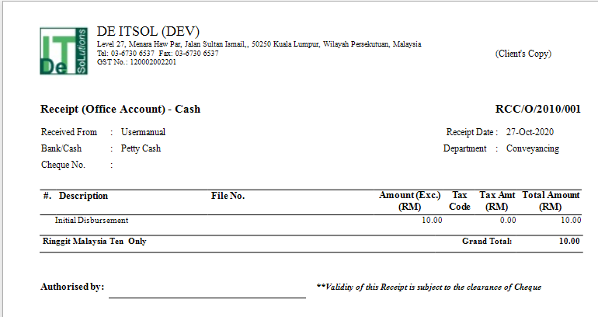

**8.1.3 New Receipt (Clients’ A/C) – MHIT**

This function should be used to generate receipt when the transaction is related to money hold in trust (Stake holder’s money).

* To begin, choose ‘**New Receipt (Clients’ A/C) – MHIT** ’.
* Receipt No. is mandatory (auto generate or manual type in is according to ref no setup).
* In the pop-up window will display as below, fill in necessary information.

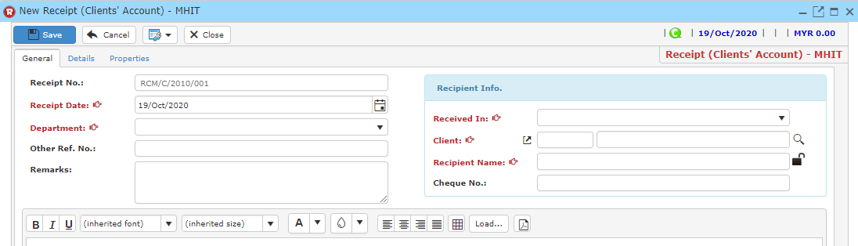

* An item must be added to the receipt to generate receipt. Click ‘**Details**’ tab, a form as shown in ‘*Figure: Receipt-Details’* will show up.

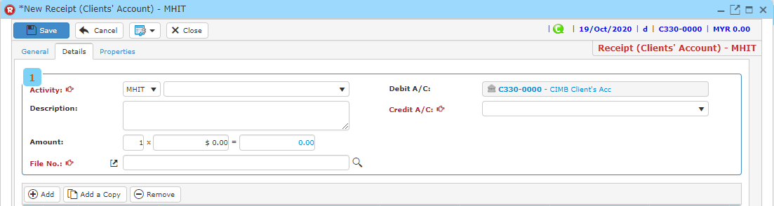

* Type amount for each item in the receipt.
* Click ‘**Add’** button to add item into the record list.
* You may also click ‘**Remove**’ button after clicking on the item that you wish to remove to remove the item from the record list.
* Then, click button to search file no.
* Enter searching criteria then click the ‘**Search**’ button.



* A result list will be displayed and choose the file you want to be linked with the receipt.



* Click ‘S**elect & Close**’ to proceed.
* Once you have completed, click ‘**Save**’ to save receipt information.
* Click ‘**Preview**’ to have a look at the receipt, and you may print out there receipt here.

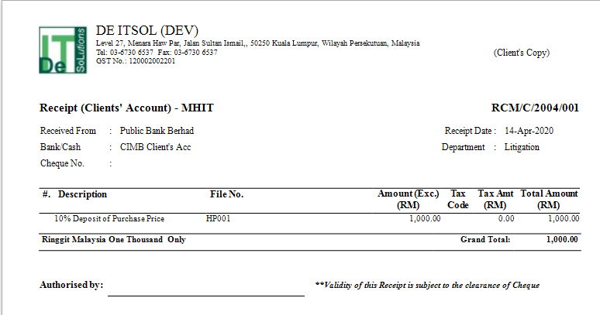

**8.1.4 New Receipt (Clients’ A/C) – Others**

This function should be used to generate receipt if non-of the payment terms meets the other options.

* To begin, choose ‘**New Receipt (Clients’ A/C) - Others**’.
* Receipt No. is mandatory (auto generate or manual type in is according to ref no setup).
* In the pop-up window will display as below, fill in necessary information.

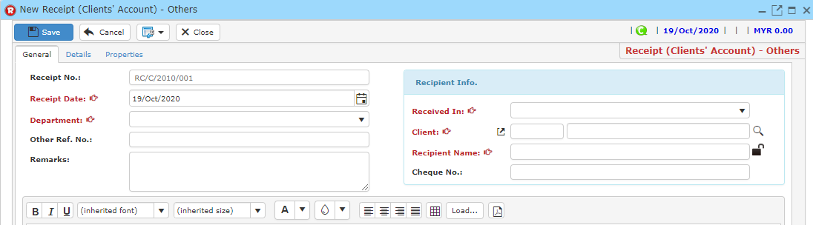

* An item must be added to the receipt to generate receipt. Click ‘**Details**’ tab, a form as shown in ‘*Figure: Receipt-Details’* will show up.

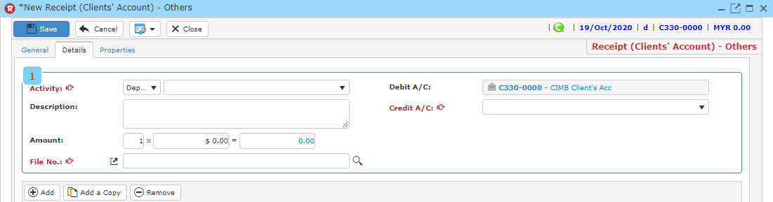

* Type amount for each item in the receipt.
* Click ‘**Add’** button to add item into the record list.
* You may also click ‘**Remove**’ button after clicking on the item that you wish to remove to remove the item from the record list.
* Then, click button to search file no.
* Enter searching criteria then click the ‘**Search**’ button.



* A result list will be displayed and choose the file you want to be linked with the receipt.



* Click ‘S**elect & Close**’ to proceed.
* Once you have completed, click ‘**Save**’ to save receipt information.
* Click ‘**Preview**’ to have a look at the receipt, and you may print out there receipt here.

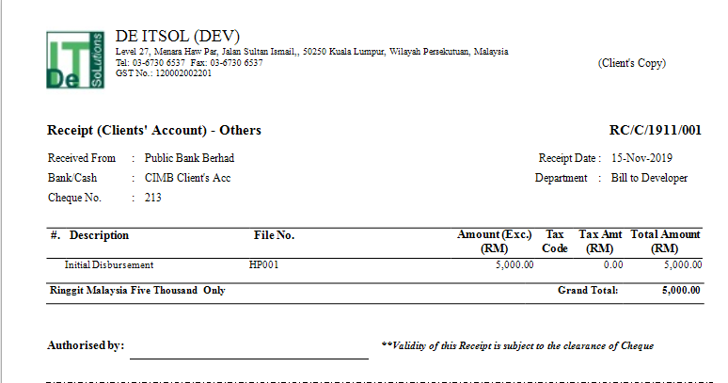

**8.1.5 Manage Receipt**

* To find a receipt, on the ‘**Receipt**’ Menu, click ‘**Manage Receipt**’.



* Type your search criteria to begin.

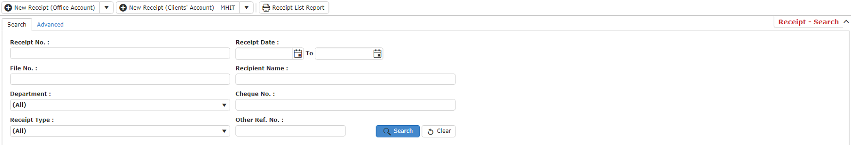

* Click ‘**Search**’ and search results will display at search record list. You can open an item in the search results list by double-clicking.
* Click ‘**Export**’ to print the desired search result in excel, pdf or csv format.

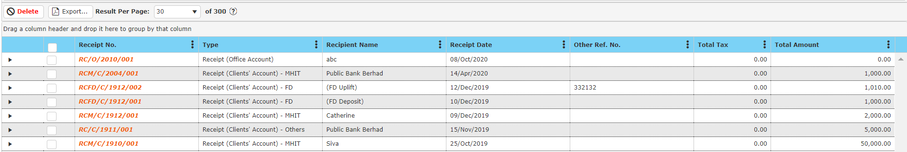

* After double clicking an item, click ‘**Preview**’ to print the desired search result.
* To start a new search or to clear the search results, close the pop-up window and click ‘**Clear**’.

**Delete Receipt**

* To delete a receipt, select the receipt in the search record list after entering search criteria in the ‘**Manage Receipt**’ by ticking the box and click ‘**Delete**’.

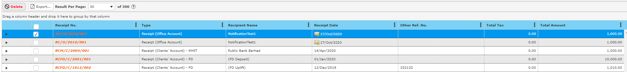

**8.2 A/R Receipt**

* To Open **Receipt** window, Click ‘**Receipt**’ on the navigation bar.



**8.2.1 New A/R Receipt (Office A/C)**

This function should be used to generate Account Receivable receipt for Office Account.

* To begin, choose ‘**New A/R Receipt (Office A/C)**’.
* In the pop-up window will display as below, fill in necessary information.

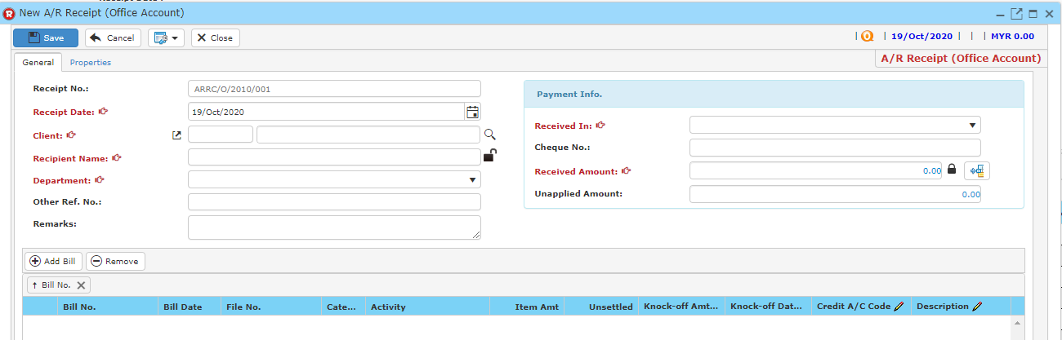

* Receipt No. is mandatory (auto generate or manual type in is according to ref no setup).
* Then, click button to search for a client.
* A window will pop-up as below.

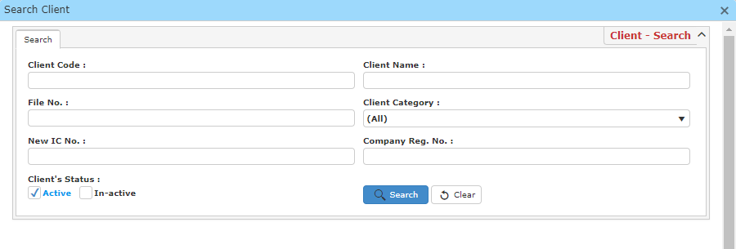

* In ‘Search Client’, Enter any search criteria to find your client.
* A result list will be displayed and choose the client you want to be linked with the receipt.

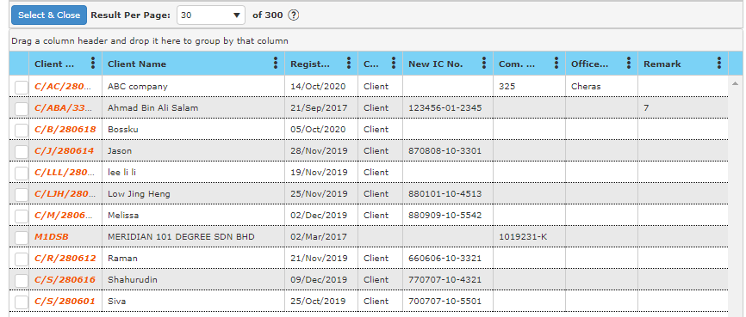

* Choose a client and click ‘S**elect & Close**’ to proceed.
* Click **Add Bill**.

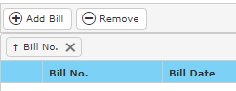

* Enter your search criteria and click **Search** and select the relevant bill by ticking the checkbox and click **OK**.

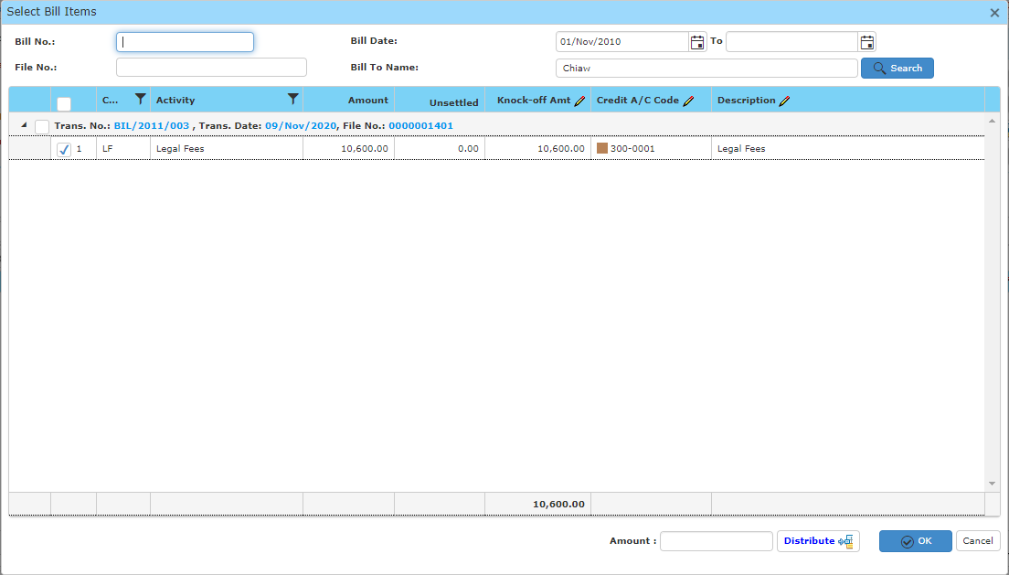

* You may also enter the amount the client is going to pay by entering in the text field for **Amount** and click **Distribute**. Please take note that the outstanding balance will goes to the last item that is selected as last item.
* Once you have completed, fill in other information needed.
* Click ‘**Save**’ to save receipt information.
* Click ‘**Preview**’ to have a look at the receipt, and you may print out there receipt here.

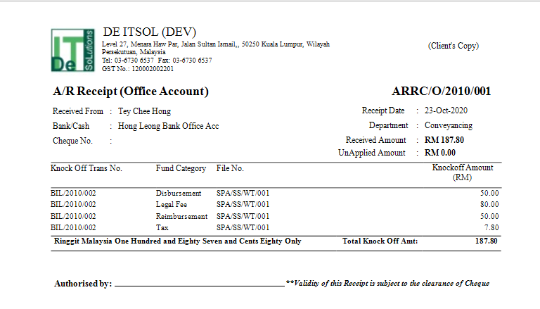

**8.2.2 New A/R Receipt (Clients’ A/C)**

This function should be used to generate Account Receivable receipt for Clients’ Account.

* To begin, choose ‘**New A/R Receipt (Clients’ A/C)**’.
* In the pop-up window will display as below, fill in necessary information.

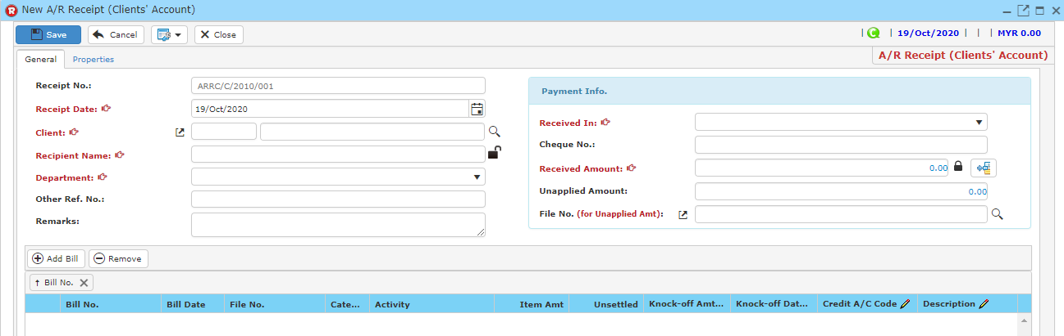

* Receipt No. is mandatory (auto generate or manual type in is according to ref no setup).
* Then, click button to search for a client.
* A window will pop-up as below.



* In ‘Search Client’, Enter any search criteria to find your client.
* A result list will be displayed and choose the client you want to be linked with the receipt.



* Choose a client and click ‘S**elect & Close**’ to proceed.
* Click **Add Bill**.



* Enter your search criteria and click **Search** and select the relevant bill by ticking the checkbox and click **OK**.



You may also enter the amount the client is going to pay by entering in the text field for **Amount** and click **Distribute**. Please take note that the outstanding balance will goes to the last item that is selected as last item.

* Once you have completed, fill in other information needed.
* Click ‘**Save**’ to save receipt information.
* Click ‘**Preview**’ to have a look at the receipt, and you may print out there receipt here.

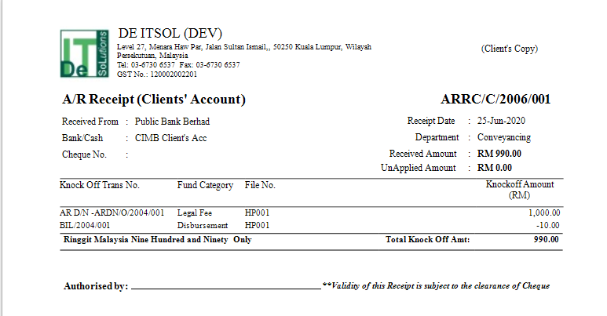

**8.2.3 Manage A/R Receipt**

* To find an A/R receipt, on the ‘**Receipt**’ Menu, click ‘**Manage A/R Receipt**’.



* Type your search criteria to begin.

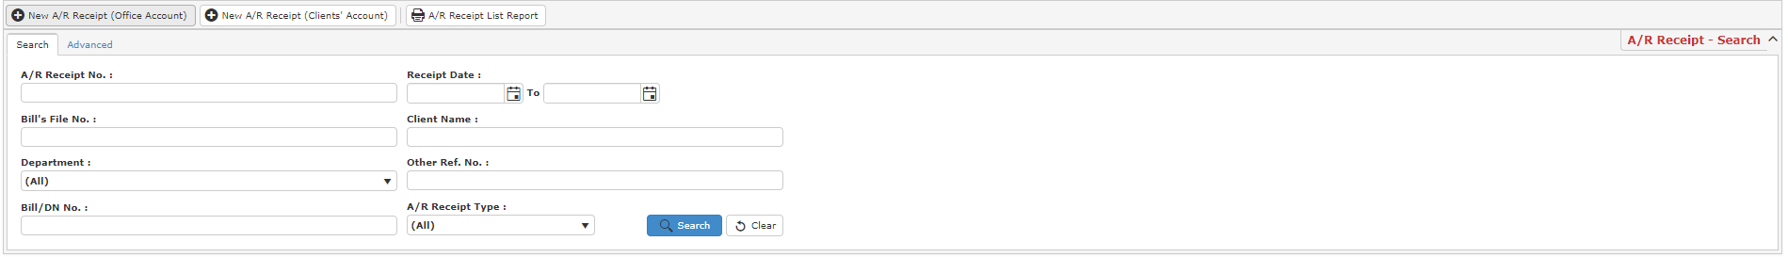

* Click ‘**Search**’ and search results will display at search record list. You can open an item in the search results list by double-clicking.
* Click ‘**Export**’ to print the desired search result in excel, pdf or csv format.

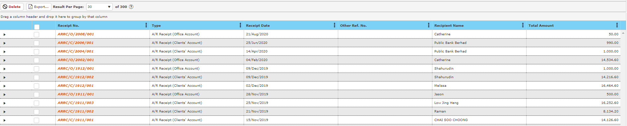

* After double clicking an item, click ‘**Preview**’ to print the desired search result.
* To start a new search or to clear the search results, close the pop-up window and click ‘**Clear**’.

**Delete A/R Receipt**

* To delete an A/R receipt, select the A/R receipt in the search record list after entering search criteria in the ‘**Manage A/R Receipt**’ by ticking the box and click ‘**Delete**’.



**8.3 Contra Bill**

* When you are using the contra bill function, please take note of certain criteria. For instance, you may be using Stake holder Money to pay for a bill.
* To Open **Contra Bill** window, Click ‘**Receipt**’ on the navigation bar.



**8.3.1 New Contra Bill (Clients’ A/C)**

This function should be used to generate Contra Bill for Clients’ Account.

* To begin, choose ‘**New Contra Bill (Clients’ A/C)**’.
* In the pop-up window will display as below, fill in necessary information.

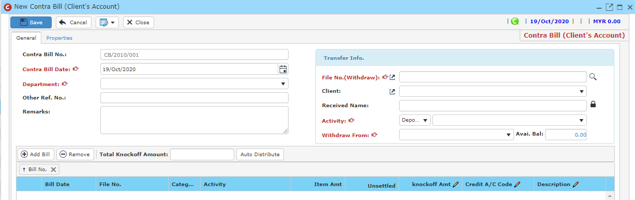

* Receipt No. is mandatory (auto generate or manual type in is according to ref no setup).
* When you are making a contra bill, please make sure that the file you choose has higher available amount comparing to the knock off amount. You may check the available balance of the file here.

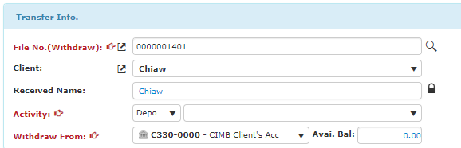

* Click button to search for a file.
* A window will pop-up as below.

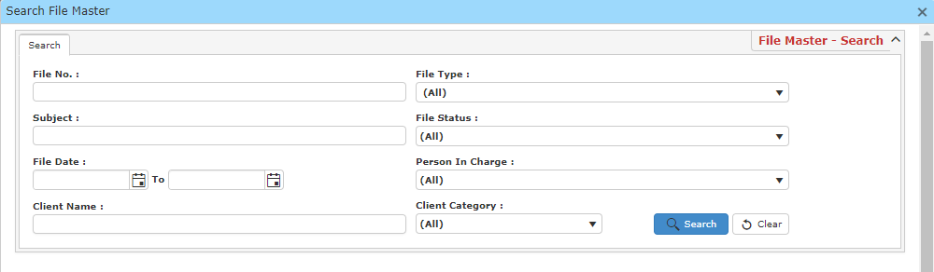

* In ‘Search File Master’, Enter any search criteria to find your file.
* A result list will be displayed and choose the file you want to be linked with the receipt.

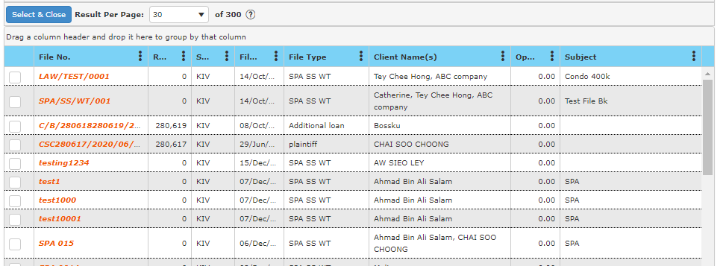

* Choose a client and click ‘S**elect & Close**’ to proceed.
* Then, click **Add Bill**.

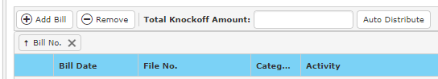

* Enter your search criteria and click **Search**. Then select the correct bill to be linked with the contra bill. You may also enter the amount the client is going to pay by entering in the text field for **Amount** and click **Auto** **Distribute**. Please take note that the outstanding balance will goes to the last item that is selected as last item.

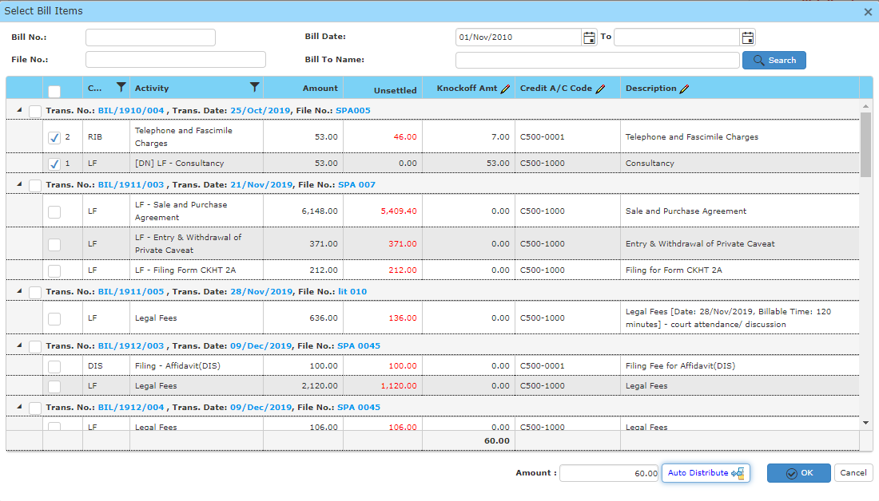

* Once you have completed, fill in other information needed.
* Click ‘**Save**’ to save receipt information.
* Click ‘**Preview**’ to have a look at the receipt, and you may print out there receipt here.

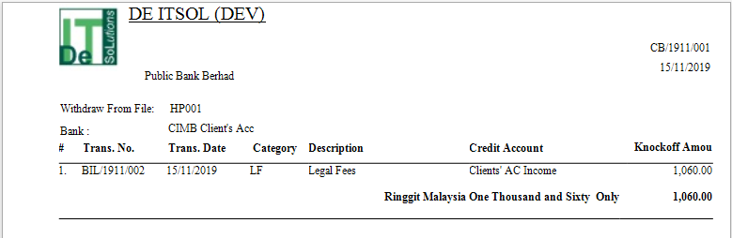

**8.3.2 New Contra Bill (Office A/C)**

This function should be used to generate Contra Bill for Office Account.

* To begin, choose ‘**New Contra Bill (Office A/C)**’.
* In the pop-up window will display as below, fill in necessary information.

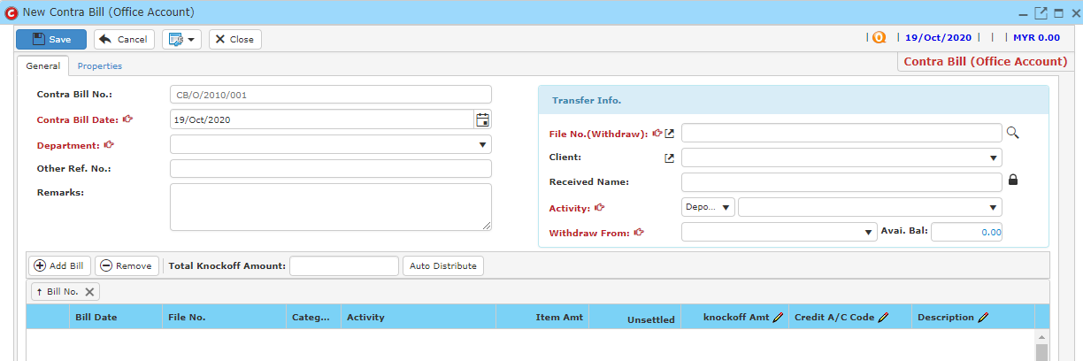

* Receipt No. is mandatory (auto generate or manual type in is according to ref no setup).
* When you are making a contra bill, please make sure that the file you choose has higher available amount comparing to the knock off amount. You may check the available balance of the file here.



* Click button to search for a file.
* A window will pop-up as below.



* In ‘Search File Master’, Enter any search criteria to find your file.
* A result list will be displayed and choose the file you want to be linked with the receipt.



* Choose a File and click ‘S**elect & Close**’ to proceed.
* Click **Add Bill**.



* Enter your search criteria and click **Search**. Then select the correct bill to be linked with the contra bill. You may also enter the amount the client is going to pay by entering in the text field for **Amount** and click **Auto Distribute**. Please take note that the outstanding balance will goes to the last item that is selected as last item.



* Once you have completed, fill in other information needed.
* Click ‘**Save**’ to save receipt information.
* Click ‘**Preview**’ to have a look at the receipt, and you may print out there receipt here.

**8.3.3 Manage Contra Bill**

* To find a Contra Bill, on the ‘**Receipt**’ Menu, click ‘**Manage Contra Bill**’.



* Type your search criteria to begin.

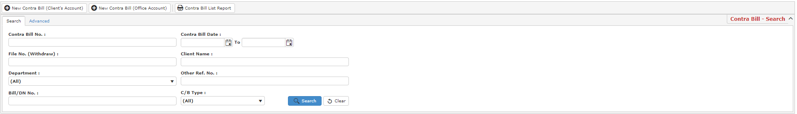

* Click ‘**Search**’ and search results will display at search record list. You can open an item in the search results list by double-clicking.
* Click ‘**Export**’ to print the desired search result in excel, pdf or csv format.

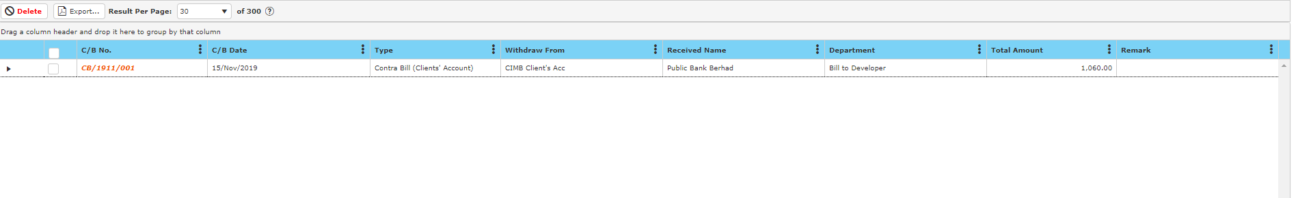

* After double clicking an item, click ‘**Preview**’ to print the desired search result.
* To start a new search or to clear the search results, close the pop-up window and click ‘**Clear**’.

**Delete Contra Bill**

* To delete a contra bill, select the contra bill in the search record list after entering search criteria in the ‘**Manage Contra Bill**’ by ticking the box and click ‘**Delete**’.



**8.4 Cheque Return Function**

* If the cheque is bounced back from the bank. You may display returned cheque date with the Cheque Return function.
* Go to the specific receipt and click.
* Choose show returned cheque date.

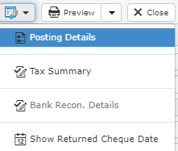

* Under recipient info, a new text field, “Returned Cheque Date” will be added.
* Click **Edit** and enter the returned cheque date.
* Enter the cheque returned date.
* Click **Save** once you have completed.

**Sample:**

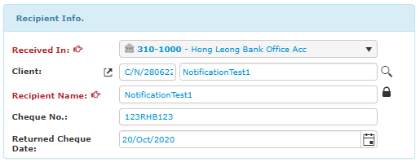

**8.5 Mange Returned Cheque**

* To manage a returned cheque, go to **Manage Receipt** and a window will be displayed as below.

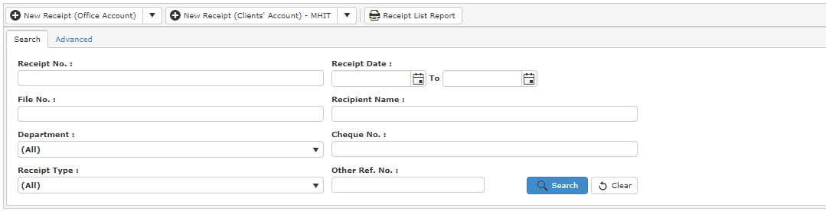

* Click **Advanced.**
* In field, choose returned cheque, fill in a value and click **Add Criteria**.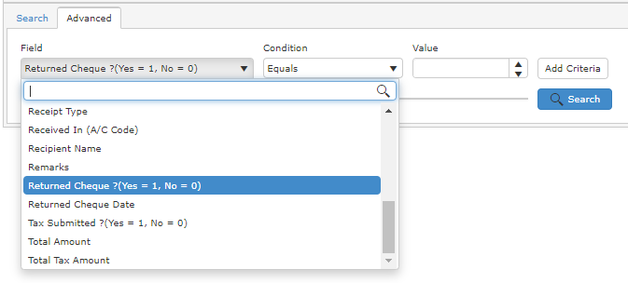
* Click **Search** and a result list will be displayed.

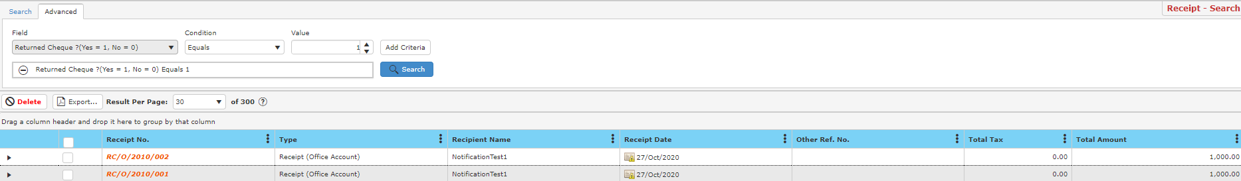

* These are the receipt with returned cheque.